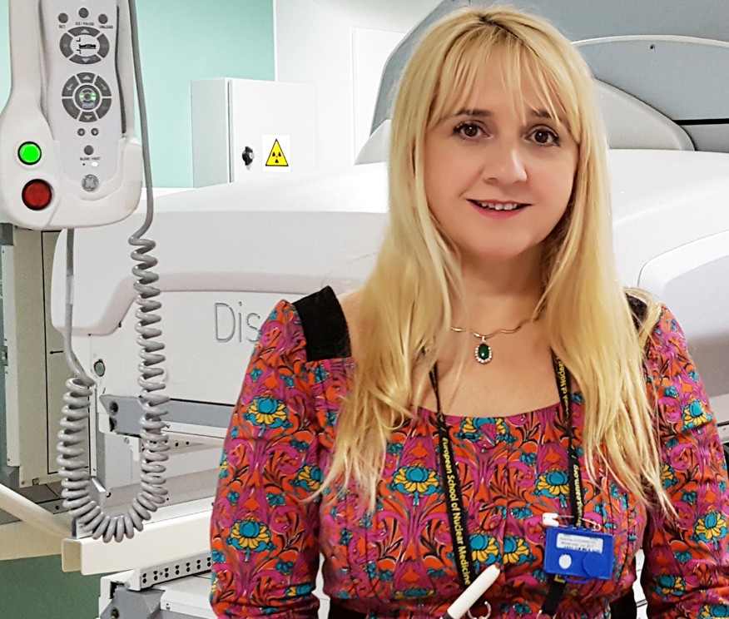

Brighton and Sussex Medical School
Honorary Titles Handbook 2023
Contents
What is an Honorary Title? 2
Benefits of Being an Honorary Title holder 2
Honorary Titles Grading 3
In training academic titles (3years) 3
Senior academic titles (3 – 5 years) 3
Title holder expectations 4
Terms of appointment 4
Honorary Titles Sub Committee 5
Committee panel 5
Application process 6
Title renewals 6
Appointment withdrawals 7
BSMS Head of Department guidance 7
Clinical and Experimental Medicine 7
Neuroscience 7
Global Health and Infection 7
Primary Care and Public Health 8
Medical Education 8
Testimonials 9

What is an Honorary Title?
At Brighton and Sussex Medical School (BSMS), we value the significant contribution made by our colleagues from other institutions and organisations to the teaching and research activities of the medical school. In recognition of ongoing commitment to these activities, we may recommend a colleague to the University of Brighton and the University of Sussex for an honorary academic title. The University of Sussex is the awarding institution.

Benefits of Being an Honorary Title holder
Those with active honorary titles here at BSMS can access a range of benefits:
- Permission from BSMS to use the title awarded in appropriate circumstances.
- Scope to apply for research grants or funding through official University of Sussex processes as part of an existing team within BSMS (but not as the Principal Investigator).
- Access to BSMS premises and facilities as agreed.
- A BSMS login and access to academic computing and library services, including access to all electronic resources (e-journals, databases, e-books)
- General access to the University of Sussex campus and sports facilities

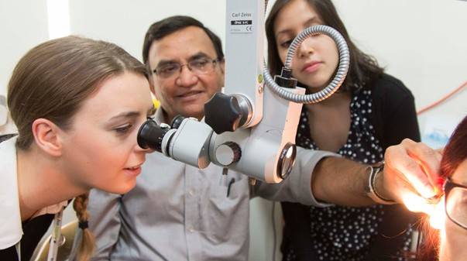

Honorary Titles Grading
Honorary titles are awarded in accordance with the level of contributions being made to the medical school and are separated by level of clinical seniority.

In training academic titles (3years)
Suitable for clinicians in training grades or non-clinical individuals working with BSMS academics:
- Honorary Lecturer
- Honorary Teaching Fellow
- Honorary Research Fellow

Senior academic titles (3 – 5 years)
Most suitable for those of an NHS consultant grade making significant contributions alongside clinical commitments:
- Honorary Professor
- Honorary Reader
- Honorary Senior Lecturer
There are three main categories for consideration of these titles. This is to allow substantive clinical colleagues who excel in one area alongside their clinical commitments to be recognised fairly for their contribution to both research and education. Impact of wider contributions will also be considered.
The three main categories are:
- Research
- Education
- Wider contributions

Leadership and Citizenship: The Committee will wish to see evidence of commitment to BSMS. This includes undertaking leadership tasks within affiliated NHS trusts fostering the causes of education and research of BSMS. Accepting tasks such as service on relevant national, regional or local bodies will be taken into consideration. The importance of these will be assessed alongside the criteria for the title being applied for.

External academic review: All applications for Professor and Reader titles are subject to external academic review by colleagues who are distinguished in their own field and understand the academic and professional field of the applicant. External academic review will be used to inform the Honorary Title Committees decisions, in particular, to assess applicants’ national and international academic profile.

Title holder expectations
BSMS expects honorary title holders to:
- Maintain a standing in their field at the level expected for the particular title awarded.
- Be subject to BSMS/University of Sussex codes of procedures governing the conduct of staff and visitors.
- Provide explicit acknowledgement of their affiliation with BSMS in publications, presentations, and other activities in the public domain, where appropriate.

Terms of appointment
- Honorary appointments are awarded only where a person is not employed by either the University of Brighton or the University of Sussex.

- An honorary title does not create or imply the creation of a contract of employment between either or both of the universities and the individual, or imply the likelihood of future employment on an equivalent substantial or any other grade. An individual who is awarded an honorary title does not thereby become an employee of either or both of the universities, nor will Statute 7 (University of Sussex) apply. No fee or honoraria is payable.

- Honorary titles should not be confused with ‘honorary academic contracts’ for staff holding substantive NHS contracts whose academic duties are explicitly incorporated in their job plan.

- Appointments are normally awarded for either three or five years. Should the contribution to BSMS be only for a specific period, the duration of the honorary title will reflect this.

- BSMS does not normally award honorary titles for unpaid contributions not directly related to teaching and/or research.

Honorary Titles Sub Committee
All enquiries and applications are processed by the BSMS honorary Titles Sub Committee. The panel meet approximately once per term where all applications are assessed to determine appropriate titles. The committee decisions are then ratified by BSMS academic board and the Dean before results are distributed to applicants.

Committee panel
Panel Member | BSMS department | Contact details
Professor Barbara Philips – Committee Chair | Clinical and Experimental Medicine | B.Philips@bsms.ac.uk
Professor Martin Llewelyn | Global Health and Infection | M.J.Llewelyn@bsms.ac.uk
Professor Anjum Memon | Primary Care and Public Health | A.Memon@bsms.ac.uk
Dr Dorina Cadar | Neuroscience | D.Cadar@bsms.ac.uk
Professor Michael Okorie | Medical Education | M.Okorie@bsms.ac.uk
Dr Ramon Fernandez | Clinical and Experimental Medicine | J.R.Fernandez@bsms.ac.uk
Olivia Cottington – committee secretary |  | BSMSHonoraryTitles@bsms.ac.uk

Application process
- All initial enquires to be submitted via BSMSHonoraryTitles@bsms.ac.uk.
  - Both the ‘BSMS Honorary Title application – Senior titles’ and the ‘BSMS Honorary Title application – training or non-clinical’ packs can be found on the BSMS ‘Honorary Status’ webpage.

- Please send in completed application form, ensuring relevant signatures are obtained in sections 6-10/7-11 alongside a copy of most recent CV.
  - For senior academic titles, additional external references are required from 5 assessors that have not been previously collaborated with. Please provide these names and contact email addresses in your application email.

- A holding email will be sent to the applicant to notify them of next committee dates and when to expect application results.

- Committee meets to assess recent applications and ascertain most appropriate title.

- Committee decisions are reviewed and ratified by BSMS academic board and the medical school Dean.

- Application outcome letters are distributed to all applicants detailing:
  - Committee decisions.
  - Term of tenure length (either 3 or 5 years).
  - Right to work check.

The committee aims to assess candidates for the honorary title applied for, the committee reserves the right to offer a different title if the application is more suited to a different level. Applications not reaching the standards required will be rejected.

Title renewals
For title renewal applications or consideration of honorary title promotion applications are due for consideration at least three months before the end of the current term of tenure. The committee does aim to contact title holders prior to their expiration of term, however ultimately it is the title holder’s responsibility to apply for a renewal if they wish to continue their honorary status with BSMS past their initial expiry date. If the committee does not receive a renewal application within 6 months post expiry, title holders will be formally removed from BSMS records.

Appointment withdrawals
Honorary appointments will be withdrawn when:
- The period for which the title was granted has expired and within 6 months has not been renewed.
- Specific requirements on the basis of which the title was awarded cease to be met.
- The title holder resigns or retires from the substantive post to which the title is related.
- The honorary title holder accepts a contract of employment with either the University of Brighton or the University of Sussex.
- The Dean of BSMS, in conjunction with the Vice-Chancellors of the Universities of Brighton and Sussex, retains the right to terminate or suspend an honorary or visiting title at any time should particular circumstances dictate this.

BSMS Head of Department guidance
All honorary title applications require sign off from correlating BSMS head of department. We understand that this may be confusing for external staff therefore applicants may find it useful to refer to the information below.

Clinical and Experimental Medicine
Professor Andrea Pepper & Professor Somnath Mukhopadhyay
A.Pepper@bsms.ac.uk S.Mukhopadhyay@bsms.ac.uk

Our research in clinical and experimental medicine comprises biomedical ethics, our Clinical Trials Unit, oncology, paediatrics, surgery, hepatology and rheumatology. Much of our research in these areas is recognised both nationally and internationally.

Neuroscience
Professor Andrew Dilley
A.Dilley@bsms.ac.uk

From the laboratory through to clinical studies, our groundbreaking neuroscience research explores the function of the nervous system in both health and disease.
Our strengths in neurodegeneration (Centre for Dementia Studies and Motor Neurone Disease), biological psychiatry and neuroimaging (CISC) underpin our ethos of ‘from bench to bedside'.

Global Health and Infection
Professor Gail Davey
G.Davey@bsms.ac.uk
The Global Health and Infection department runs a vibrant research programme with academic links around the world via the Brighton and Sussex Centre for Global Health Research and the NIHR Unit for Neglected Tropical Diseases. Crosscutting themes such as ethics and mental health ensure we have strong collaborations with colleagues in other departments across the Universities of Brighton and Sussex.

Primary Care and Public Health
Professor Carrie Llewellyn
C.D.Llewellyn@bsms.ac.uk

We believe that place-based population health lies at the heart of effective healthcare. Our teaching and research across primary care and public health help us develop ways to evaluate and improve the health and healthcare of all, particularly the most vulnerable, stigmatised and underserved, such as people living in deprived coastal communities. The Department of Primary Care and Public Health hosts experts across a wide range of disciplines and methodologies to address healthcare challenges across the lifespan. These include general practice, public health, epidemiology, medical statistics, data science, psychology and behavioural medicine in an ongoing dialogue between teaching, research and clinical work, with a focus on addressing health inequalities.

Medical Education
Professor Gordon Ferns
G.Ferns@bsms.ac.uk

Medical education research at BSMS has developed along with the undergraduate BM BS programme through the Department of Medical Education, a multi-professional group involved in undergraduate and postgraduate teaching and learning.
Medical education research is being conducted as part of doctoral studies (MD/PhD/Professional Doctorate) and Masters programmes, as well as in collaboration with parent universities, by a multi-professional group of academics and clinicians.

Testimonials
Read the following statements from some of our current and past honorary title holders here at BSMS:

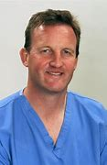
Professor David Howlett
Honorary Clinical Professor, BSMS,
and Consultant Radiologist East Sussex
Healthcare NHS Trust

I’ve been involved with BSMS in a range of roles, first, as the regional Eastbourne Subdean between 2005 and 2013. I also had the opportunity to help create the Year 5 clinical and
professional studies online module, for which we developed 650 clinical cases with over 3,500 questions that covered all Year 5 specialties.
This highly important, hugely popular and effective teaching innovation has now been rolled out as an online platform and bespoke app, CAPSULE. Student utilisation has been excellent with over 35,000 cases completed in the first academic year, and student feedback is highly positive. BSMS is now looking to share this resource with other partners and interested
medical schools.
I learned about honorary titles at BSMS while I was Subdean, and was supported in my applications for the positions of
Honorary Senior Lecturer then Honorary Reader. I’m very grateful for the support and guidance BSMS gave me in my transition to Honorary Clinical Professor in 2014.
As a radiologist in a district general hospital (DGH), BSMS has provided me with tremendous opportunities to enhance my professional role and become involved in undergraduate education and research.
Teaching is rewarding – we are fortunate in having a relatively new and innovative medical school on our doorstep and I would strongly encourage colleagues in other regional centres and DGHs to consider how they can become further involved within BSMS.

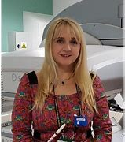

Dr Sabina Dizdarevic
Honorary Clinical Reader, BSMS,
and Principal Lead Consultant in
Imaging and Nuclear Medicine, Brighton and Sussex University Hospitals NHS trust

I have been an Honorary Clinical Reader at BSMS for the past two years, following 11 years as an Honorary Senior Lecturer. I have always been passionate about research and teaching, and it was natural for me to combine my clinical work with academia.
I am involved in a range of activities at the medical school, such as BSMS PET-CT Clinical Lead at the Clinical Imaging Sciences Centre (CISC), Chair of the CISC Clinical Executive Group and a member of CISC Management Group.
I have helped with undergraduate curriculum planning by
preparing case studies and Imaging practicum for the phase 3 Imaging curriculum, and I supervise students in their fourth year individual research project.
I have taught on a number of postgraduate courses. I regularly give lectures on multimodality molecular functional imaging and nuclear medicine theranositcs for the MSc in Dementia Studies and Oncological Imaging.
I have also been an Academic, Educational and Clinical supervisor for 16 BSMS Academic F2 trainees, who have gone on to win some very distinguished national and international awards.
I really enjoy the research environment and collaboration with senior academic colleagues at BSMS. Interactions with medical students, clinical academic research trainees and fellows and postgraduate students, who are full of enthusiasm and eager to learn, achieve excellence and develop their knowledge, skills and career, certainly brings me immense work

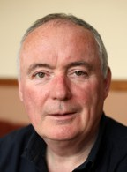
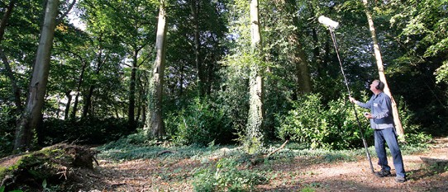

Mark Ware
Honorary Research Fellow, BSMS, and audio-visual artist, supported by Arts Council England

I’ve been an Honorary Research Fellow at BSMS for the past four years. I work collaboratively with members of the BSMS Department of Neuroscience and the Sackler Centre
of Consciousness Science on experimental and arts-science, exploring the interface between aesthetics, perception
and brain, relevant to the arts, consciousness science and neurological function and dysfunction.
The way I think about and produce art has been profoundly affected by my collaborations with the neuroscience team. We have managed to develop a working relationship that places a great emphasis on cross-disciplinary ways of thinking that have begun to deliver some extremely exciting results. I genuinely feel honoured to have been offered this opportunity.

