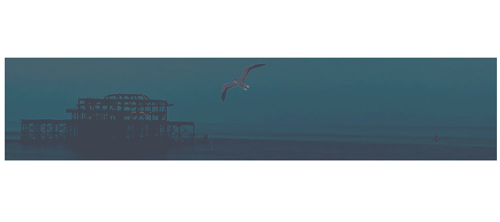
CERTIFICATE OF ATTENDANCE

This is granted to

NAMEHERE

for attending the 21st International Symposium on Recent Advances in Otitis Media: Virtual Meeting on 11-12 June 2021.

PROFESSOR MOOD BHUTTA


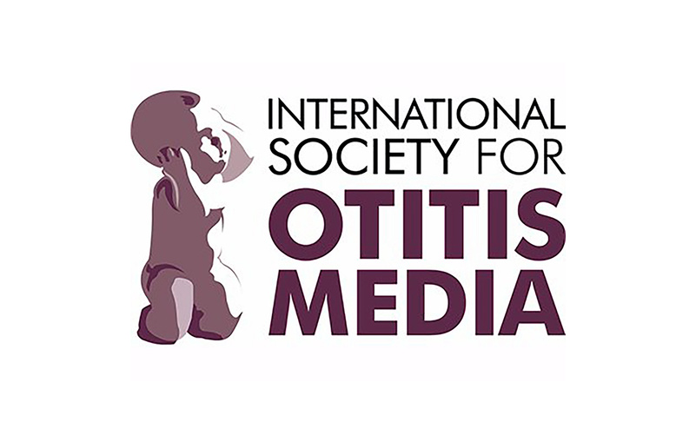
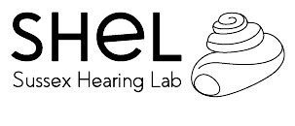
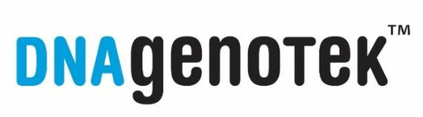
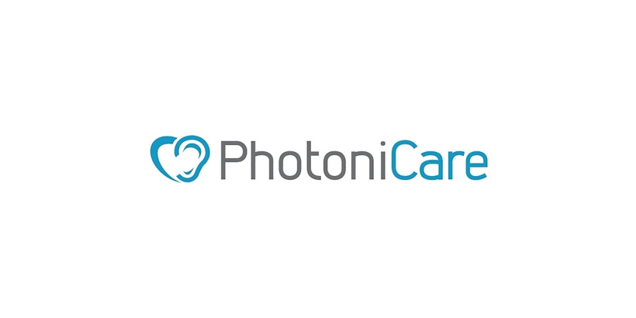
Chair of the 2021 Otitis Media conference

