Health Education Conference

This varied and interactive one day conference and networking event is organised by Brighton and Sussex Medical School.

Explore research into innovative clinical education topics through keynote presentations, facilitated discussions, workshops and delegate talks.
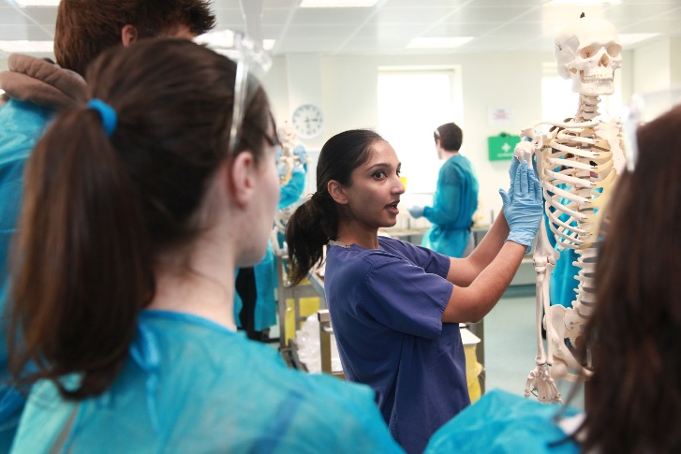

Topics

Our interactive workshops will cover:
- inter-professional integration
- leadership in clinical education
- technology enhanced learning
- undergraduate assessment

Who should attend?

Everyone who is engaged with teaching and learning within the healthcare sector.

Certification

5 external CPD points from RCP London. Attendance certificates will be issued.

When & where will it run?

Friday 8 December 2017, 9am – 5pm

Sussex Conference Centre
3rd Floor, Bramber House
University of Sussex
Brighton, BN1 9QU
How much will it cost?

BSMS are able to offer FREE attendance to all delegates, thanks to our generous event exhibitors.

Space is limited so register soon!

More info & registration

All delegates, including presenters, must register at: bit.ly/HEC17

Contact

healtheducationconference@bsms.ac.uk

Sponsors

