|  |
| --- |
|  |
| Image result for brain wallpaper |

**MS-FIN**

**The Role of Interoception in Multiple Sclerosis Fatigue**

**Introduction**

How is fatigue is represented in the brain?

Are the neural pathways informing the brain about the body different in people with multiple sclerosis who experience fatigue?

These questions are addressed by MS-FIN - a study on the neural basis of fatigue in multiple sclerosis

**Get in touch**

If you want to find out more about the project, please get in touch with the team, via:  
  
*Dr Iulia Bogdan*  
Neurology Research Fellow  
Clinical Imaging Science Center  
Knightsgate Road, Falmer Campus, University of Sussex Brighton BN19RR  
Tel: 01273876720   
E-mail: [bsms9246@bsms.ac.uk](mailto:bsms9246@bsms.ac.uk)

**Taking part in the study**

If you have relapsing-remitting multiple sclerosis (with or without fatigue) and would like to take part in the study, please contact us!

**More about the Study**

**Where does the study take place?**

The study will take place at the Clinical Imaging Sciences Centre, on the University of Sussex campus, Brighton, BN19RR

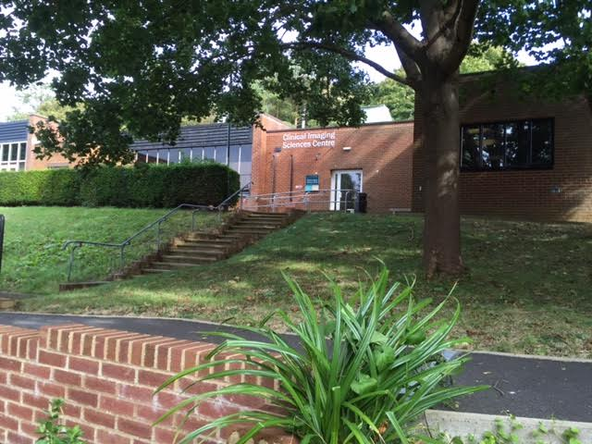

**What would I have to do, once in the study?**

* Will be invited to two visits, lasting about 1.5 hours each (2 weeks apart from each other)
* Will have MRI, mental tasks and questionnaires

**What new evidence will the study bring?**

The study will bring new understanding into the mechanisms of fatigue in MS. This knowledge could be used in future research aimed at finding effective treatments for MS fatigue.





*Thank you!*