

Can you help us find out how the brain processes ….? <insert details relevant to your project here>
We are looking for healthy participants to take part in a study which aims to understand how the brain <insert details of your study here>.
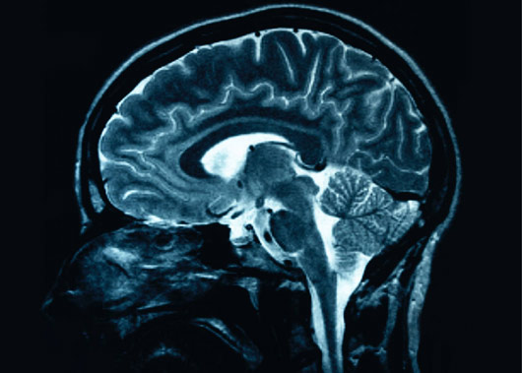

Sample text:
Taking part involves a 45 min training task using desktop virtual-reality and then having your brain scanned in an MRI scanner for around 45 mins whilst you perform a test <insert name of test>. The total time for the session is up to 2 hours.

We will pay £20 for your time (£10 per hour), and you will be offered a picture of your brain should you wish to have a copy.

For more information please contact:
Dr A Researcher (a.researcher@bsms.ac.uk)

This study has been approved by the Brighton and Sussex Medical School, Research Governance and Ethics Committee.

<Version 1>.
<Date>

