Project: | Selsey One Stop Care Shop - Combatting loneliness in rural communities
Team: | Selsey Community Forum: Mike Nicholls, Karen Pirks, Lisa Allison, Sue Hancock, Ronelle Juleff
Contact for further information: | Mike Nicholls; mail@selseycommunityforum.uk
KSS DCIN Fund: | Award £5,000

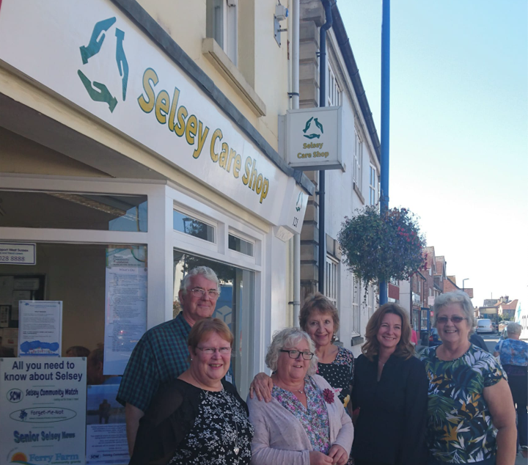

Background

At the first KSS Dementia Care Improvement Network Event, held in September 2018 Mike Nicholls and his colleagues from the Selsey Community Forum applied for funding to extend dementia services of the Selsey Care Shop to the rural and isolated area west of Selsey at the southernmost tip of the Manhood Peninsula.

The team pitched for funding to bring under one roof, support for those living with dementia and their carers. Working in partnership with the Alzheimer’s Society and Carers Support West Sussex as well as local support groups, the group’s aim was to fund two part time staff and fifteen volunteers creating a friendly community shop providing a range of services and support. These services included provision of community information, dementia friendly activities such as a cinema/lunch club and even daily telephone calls to combat loneliness. With some funding already secured, the team required a small additional resource to complete their team with a Carers Outreach worker.

Learning from testing this approach could then be used as a template for other rural towns.

What happened

The aim of the Care Shop is to offer 5 services under one roof;
- creating a dementia friendly community
- providing complementary information on available support
- providing social activities
- improving face to face consistent support
- offering a template for local neighbouring parishes

The Selsey Care Shop has been developed with a staff of 6 and 80 volunteers. Activities offered have emphasised social interaction. The shop has provided men’s activities, music, links to care homes, a young people’s group, engaging in inter-generational work, dementia friends sessions, interaction with local businesses, support groups for carers and home visits, telephone calls, visits and face to face interventions.

By bringing capacity and these activities together under one umbrella, the group has benefited from co-ordinated partnerships with the Alzheimer’s Society, Crossroads Care, Carer Support West Sussex and Sage House Wayfinders Outreach Workers.

Demand was unexpectedly high and a challenge to meet within the limited staff capacity. Per month the shop sees 400 people, conducts 1200 phone interactions and in addition local people drop in. It has received 103 dementia referrals.

The experience of the Care Shop team has confirmed how close personal interaction is hugely important on the dementia journey and that this is a message that they are spreading to other services. They are now replicating models in neighbouring parishes.

Ongoing funding and sustainability is an ongoing issue for the service. Mainstream funding as well as National Lottery funds are being sought.

Being involved with KSS DCIN had been a positive experience for the service. It has exposed the group to a wider professional network they would not have otherwise discovered and driven up standards.

