Project: | Rhythmix Music
Team: | Sussex Community NHS Trust, Alison Keizer, Jo White, Teresa Fitton
Contact for further information: | Alison Keizer, alisonkeizer@nhs.net;  Jo White https://wishingwellmusic.org.uk/
KSS DCIN Fund: | Award £4,840.00
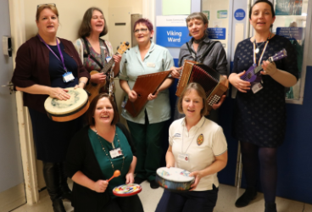

Background

Alison Keizer, Dementia Lead at Sussex Community NHS Trust and Jo White from Rhythmix Music applied for funding for a 15-week programme of participatory music at Crawley Hospital.

Following the successful Rhythmix ‘Wishing Well’ music programme at Arundel community Hospital, the aim was to use making music as a relational tool, using voices, musical instruments and ipads, to bring music making activities to patients’ bedsides. The wider aim being to improve patient mood, self expression and communication and to improve staff wellbeing and further understanding of how music making can benefit people with dementia in a community hospital setting.

The musicians were trained specifically to work with people with dementia and take music making beyond simple entertainment to create person centered interactions that support wellbeing and engagement.

What Happened

Between February and April 2019, 10 participatory music sessions for patients,
families and staff at Crawley Hospital were delivered. Sessions were led by two Musicians in Healthcare, supported by an Occupational Therapist. The team worked with a total of 79 patients over this time, seeing some people several times over the 10 weeks, building up a picture of their musical world, the songs that were meaningful to them and the instruments they enjoyed playing. The team saw some people just once or twice but the experience of making music together had an impact on their experience in hospital nonetheless.

The Rhythmix team used special instruments that require no previous experience, this meant that patients were able to improvise and engage quickly with the music making. During the project the musicians took feedback and staff observations to evaluate the extent to which the music making had reduced people’s anxiety, helped them to express themselves and created a sense of community. The feedback suggested that those outcomes had been met.

Alison confirmed that, although initially wary, staff had been won over by the project so staff engagement was high and the dynamic in the ward was noticeably changed when the musicians were with patients. Alison also said there was a sense of calm from patients and from staff. Family members were also very engaged with the project.

Learning

Previous studies have evidenced the benefits of music as a relational tool for people with dementia, and the feedback from this project further evidenced that. However, there is a longer term is a challenge in sustaining the engagement with music making once the specialist group are no longer on the ward. A role of ‘music link nurse’ could be developed and taken by a specific member of staff. Although the skill set is not about being an accomplished musician it is about confidence and relating to people through music.

The hospital team are now making efforts to secure further funding to continue the work started by the musicians. They are seeking funding to buy Tablets/I-pads and aim to train music link volunteers to be on the wards to continue the work. Following further evaluation, they aim to extend the project to all the other in-patient units within the hospital.

