Project: | Dementia Information Pop Up Hubs
Team: | Worthing Dementia Action Alliance, Jacqui Swindells, Lynsey Tran, Bob Smytherman
Contact for further information: | Jacqui Swindells, jacqui.swindells@abbeyfieldferring.org.uk
KSS DCIN Fund: | Award £5,000

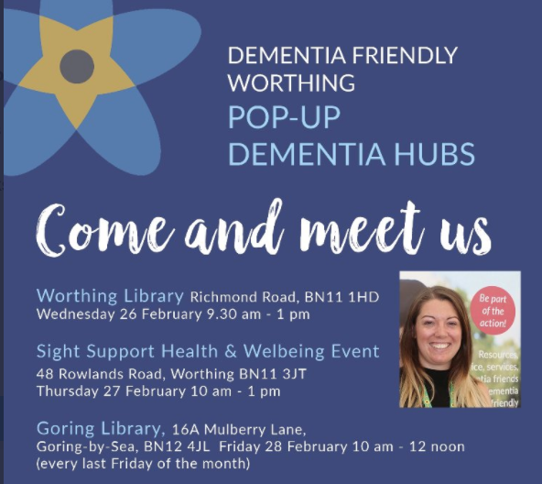
Background
Worthing Dementia Action Alliance have been providing Pop Up Dementia Information Hubs on an ad hoc basis. Data gathered through doing these pop up's indicated that people often do not retain the information they have been given after leaving dementia advisory services and/or other clinical settings. Often, they are still trying to digest and come to terms with their diagnosis. As well as people diagnosed with a dementia the Hubs also had enquiries from people concerned about their memory but were afraid to seek help and carers, especially young carers who needed help and advice on how to care for their aging loved one.
The application to the DCIN improvement fund bid was to increase the number of Pop-up Hubs and extend their reach into Adur. The Hubs would connect with the local communities, directly providing local information about dementia, dementia services, benefits, council tax information and a whole variety of topics, all dementia and carer related. Having previously run Dementia Information Hubs the team felt there was a gap in provision of more general information about the support available locally and that this information was not always available to people within clinical settings.
Offering a greater number of Pop-up Hubs would also provide the team with more data so they could conduct a systematic analysis and identify which venues, days of the week and times of the day were more popular with people seeking help.
What Happened
The team ran 46 Hubs across Worthing and Adur, engaging with 100 people.
The hubs were held in a variety of settings and at different times of the day to engage with as many people as possible. A large percentage of visitors were carers, many were family members who did not self identify as carers. In addition, the team presented 40 information sessions on the impacts of dementia to local care homes, business organisations and carers. These were sessions that originated through contacts made at the Hubs and through Dementia Friends.
A clear trend was that people were approaching the Hubs for further information as their situation and needs changed post diagnosis. In some cases, this was years after the initial diagnosis. The team needed to ensure that the information and support people were directed to was local and up to date. A lot of information requested related to benefits. Many people were surprised to find that they did not need a formal diagnosis to access support.
The Dementia Action Alliance website proved very useful, detailing services, networked groups and dates for future hubs.
Settings were key. Pop ups were held in clinical settings and community spaces. The team made efforts to run the hubs outside of working hours. Evening and days sessions held at Worthing Hospital were particularly well attended as patients and carers being discharged were able to check they had information they needed to manage at home. Linking in with other groups such as the carers’ health team at Worthing Hospital added value.
The team learnt through questionnaires that most people would usually look to their GPs for advice. As most needs expressed were social and not clinical, this would take up significant GP time. At one Hub, 8 out of 10 people had their needs met by information given at the Hub.
Key Learning about running Hubs
- make the information very specific to the local community
- be clear about what support you can and cannot offer
- run hubs in a wide variety of settings and at different times of the day
- prepare for a wide range of visitors, some of which may not identify themselves as carers but who have a caring role
- many people are not getting the welfare benefits they are entitled to so understand current benefits available and have the information to hand or partner with a benefits adviser/organisation
- make links with local GP practices and encourage them to promote the hubs to their practice population

