Project: | Side By Side: Learning and support for carers of people living with dementia
Team: | Edith Megbele & Sheila Clarke Admiral nurses, Kent and Medway NHS and Social-Care Partnership Trust  Amie Page, Team Manager, CMHTOP
Contact for further information: | Sheila Clarke, sheila.clarke6@nhs.net
KSS DCIN Fund: | April 2019: £5,000

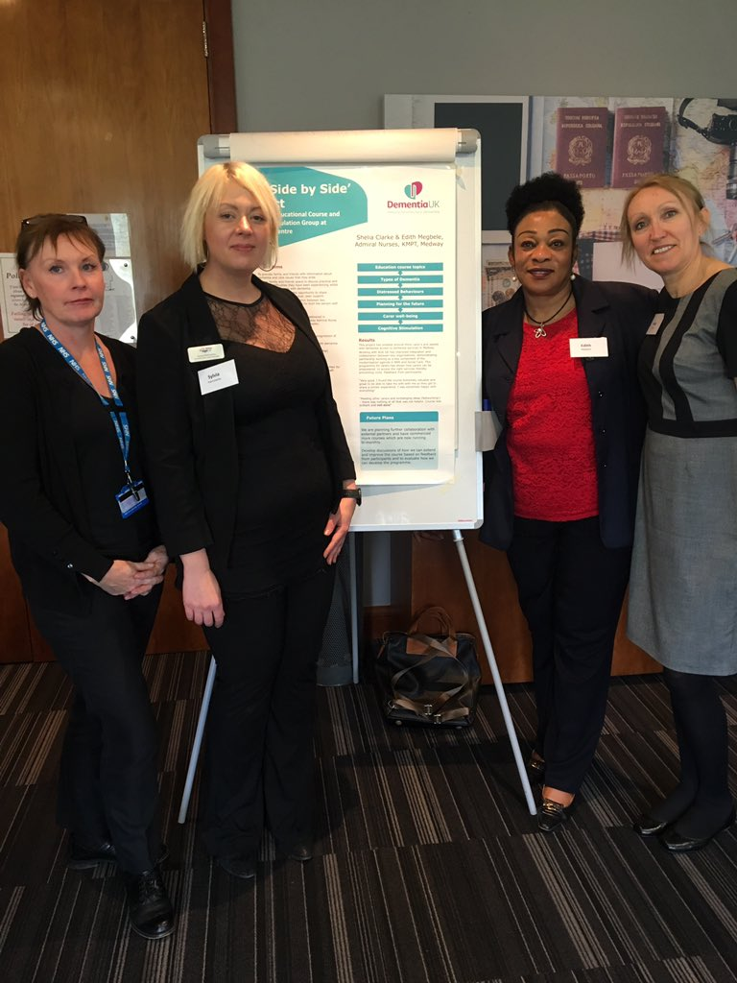
Background
Admiral Nurses working with Age UK Medway Day Centre deliver integrated and sustainable physical and mental health Dementia Services within local communities. The group wanted to improve the accessibility of local Dementia Support Services for carers and people who have dementia. Following feedback from carers that were having difficulty accessing an existing Carers Education Course, the Medway Admiral Nurses developed this ‘Joint Care Approach’ to dementia care.

The project aimed to provide a Carers Education Course, a pan educational workshop for carers and a parallel Cognitive Stimulation Group for people with dementia together at the Age UK Medway Day Centre.

The benefits of psycho-social education, dementia awareness and earlier intervention having been shown to improve the quality of life of carers and people with dementia. The project objectives were
- to improve mental health of carers and people with dementia by reducing stress related to separation
- to improve awareness of the positive interventions provided by Admiral Nurses during the educational workshop and the cognitive stimulation and socialisation provided by Capstone Day Centre.

A KMPT Service Evaluation of the Side by Side Project was also undertaken. This aimed to enable Medway Admiral Nurses to demonstrate the expertise that they provide to carers and people with dementia; develop and improve service provision; inform Health and Social Care Strategic planning throughout Kent.

What Happened
The group held nine sessions, delivered by specialist dementia nurses. Each session was attended by 25 carers and 15 people with dementia.
Sessions covered the following areas:
- Understanding the different types of dementia and the progression
- Dementia Support Service and Social Services
- Understanding behaviours that challenge and ways to respond
- Carers First – Medway/Benefits Advice
- Managing finances and Power of Attorney
- Looking after your well-being as a Carer

As well as improving knowledge the sessions aimed to empower carers to access appropriate and timely services to prevent situations escalating to a crisis.

The group believed that the keys aims of the project were achieved. The workshops provided education and information on dementia to 75 carers. They also facilitated partnership working building relationships between carers, people living with dementia and services.

Attendees reported that meeting others in similar situations to themselves was very beneficial, especially to be able to voice their concerns and fears in a safe environment. Carers describe the advantages of “getting a break” as a way to prevent carer break-down. One participant commented,
“Very informative. I would thoroughly recommend this course to everyone who has to care for a loved one with dementia.”

There was a greater demand for places than could be accommodated in the venue and there were funding challenges for the project. However, the group have now secured additional funding to continue the project from Medway CCG.

Key Learning from the project
- Importance of partnership and multi- agency working

- Opportunity to offer Admiral nurse education sessions to a large group of people

- Learning from one another and building relationships

- Carers coped better and longer due to increased knowledge of Dementia

