Project: | My Future Care - A toolkit for Advanced Care Planning
Team: | Zoe Harris, Dr Richard Haworth GP, Marti Vowles, Ruby Steel
Team Lead: | Zoe Harris, MyCareMatters CIC; info@mycarematters.org
KSS DCIN Fund: | £5,000
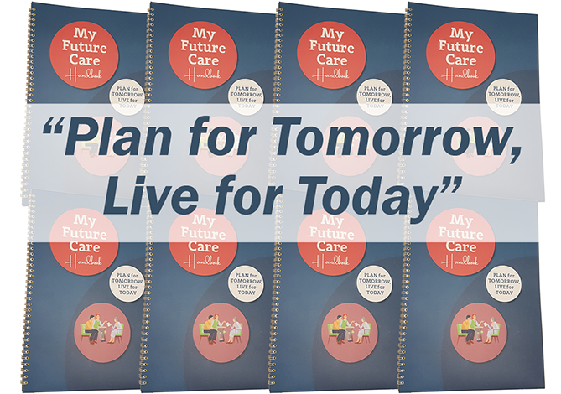
Background
Healthcare professionals working with people with a terminal diagnosis, particularly where the condition is likely to create communication challenges as it progresses such as dementia, recognise the need for raising the issues but can feel ill-equipped to do so.

My Care Matters pitched for funding to create an Advance Care Planning toolkit for people living with dementia, their families and healthcare professional interacting with them. The aim was to structure ways to start a conversation about end-of-life decisions.

‘The information regarding future planning can be overwhelming and in reality this process often happens too late’, said Zoe Harris.

Healthcare professionals report being unsure of people’s rights, responsibilities, what is legally binding, and are particularly unsure of how, where and when to open such a conversation. The Toolkit aimed to facilitate these conversations by providing an easy-to-follow process with practical tips, case studies and the facts about the different kinds of decisions that need and can be made.

Feedback gathered from workshop participants including psychologists, crisis team members and community nurses found widespread support for the idea. The Toolkit would support the idea that death is something that needs to be planned for and would enable more people to have a better end-of-life.

What Happened
The project started by ascertaining, through interviews, the current state of advanced care planning. The results showed how little people had engaged with the issues but also indicated a need to talk about living well alongside dying. On the basis of this feedback, the Advanced Care Planning Toolkit developed into the interactive My Future Care Handbook, a comprehensive collection of over 60 pages of information, useful templates and forms all gathered together in one place.
‘Forms for all things for later life and beyond, from compiling a bucket list to writing a will. From compiling a playlist to considering where you want to live and be cared for if you need support and much much more’.
My Future Care Handbook, released in February 2020 is the resource developed by Zoe Harris and her team for people living with life limiting conditions, their families and healthcare professionals interacting with them and provides a process/structure to initiate, guide and complete the conversation and record decisions taken about their future care and later life.
To extend the reach of the resource and make it accessible and available to people who might not use a digital resource, a printed version was produced. QR codes and links to online resources offer the possibility of producing an online version in future. The handbook is now available on Amazon, eBay and via a new dedicated website www.myfuturecare.org .
In order to extend the offer geographically, partnerships with other organisations have been formed, but this has been put on hold due to the pandemic. The plan is to offer via social prescription both a copy of the handbook and a face-to-face interview with a volunteer. In view of social distancing being a longer term reality the team are now looking to partner with befriending services to offer a similar experience by phone.
The response to the handbook to date has been overwhelmingly positive.
For further information please see @info@mycaremattersorg or phone 01403 210485.

