

Ethical Review

Online Application System: User Guide



Contents

Purpose of this document 3

Accessing the system 3

Setting internet browsers to check spelling 4

Creating a new Application 5

Roles 8

Ethical Review Form 9

Supporting Documents 11

Creating a merged PDF 13

Declaration 13

Amendments 14

Amendments to approved applications prior to the introduction of the ethical review system for BSMS 14

Amendments to ethical review applications approved within the BSMS ethical review system 15

# Purpose of this document

This user guide is intended to provide an overview of the University’s ethical review online application system for staff and students who are required to submit their research project for the purpose of gaining ethics approval.

This guide aims to provide an overview of the system functionality of the online ethics application process, and is not intended to provide advice or guidance about how to design a good research ethics application. Help text within the online system will assist in clarifying what is expected in each section of the application, and the University’s [*Guidelines for Completing the Online Application Form for Ethical Review*](http://www.sussex.ac.uk/res/documents/guidance_for_completing_online_application_form_august2012.pdf)provides detailed guidance and advice on specific issues relating to good practice in research ethics.

# Accessing the system

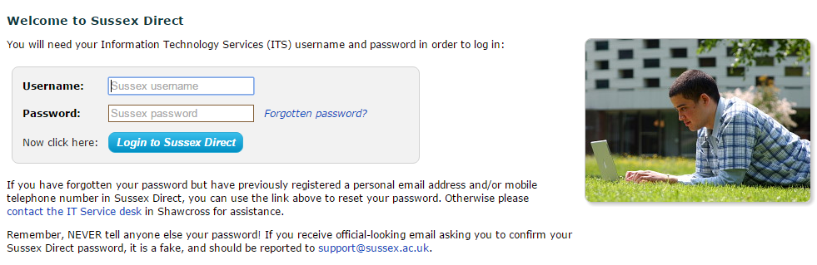

* Log into ***Sussex Direct*** via the University of Sussex website and go to ***‘Research > Ethical Reviews’***
* Alternatively you can go directly to the ethical review page by using this link: <https://direct.sussex.ac.uk/mle/page.php?realm=research&page=ethical_review_list>

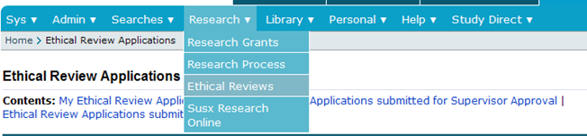

Click on ‘Research’, and then select ‘Ethical Reviews’

You will need to wait a few seconds before **My Ethical Review Applications**: ***Your name*** appears.

|  |
| --- |
| Setting internet browsers to check spelling ***Internet Explorer***  To **enable** the **spell check** feature in **internet explorer**, click on the click on gear icon, which is located towards the top right corner of the window. With the menu opened up, click on the "Manage add-ons" option. Find the “Spelling Correction” option and set English (United Kingdom) by highlighting and selecting the ‘Set as Default’ button.  ***Chrome***  Enable **Chrome's** Native **Spell**-Checker. To enable or disable **spell**-**checking**, click the **Chrome** menu button in the top right on the browser toolbar. Select Settings and at the bottom click ‘Show advanced settings’. Scroll down to Languages and click the Language and input settings… button. By default Chrome will offer English (United States). You will need to choose the Add button to pick out English (United Kingdom).  ***Mozilla Firefox***  Click on the menu button and choose ‘Options’. Select the Advanced panel. Click the General tab. Ensure that **Check my spelling as I type** is ticked. To install a specific English language dictionary, Visit the Mozilla *Dictionaries & Language Packs* page. Find in the list the language you want to add, and click the Install Language Pack link next to it. The main page of that language pack will be open.  Click the Add to Firefox button for to install it. Firefox will download the language pack and ask you to confirm the installation.  After the dictionary is installed, you can switch to it, as needed. To switch to a different installed dictionary, Right-click in a multi-line field, select Languages, then select the dictionary you want to use.  ***Safari***  Click in a text field. On the menu bar, go to **Edit / Spelling and Grammar** / ‘Check Spelling While Typing’.  To set the language checker to English UK.  Go to System Preferences. Click on 'Language and Text'. Make sure the 'Language' heading is selected.A list of languages is shown .Click on the Edit List button at the bottom of the window. Find 'British English' from the list which pops up and tick/check the box to the left of it. |

### Creating a new Application

* After logging into ***Sussex Direct*** and going into ***‘Research > Ethical Reviews’, then:***

1. **Click on the ‘New’ icon on the ‘My Ethical Review Applications’ screen:**

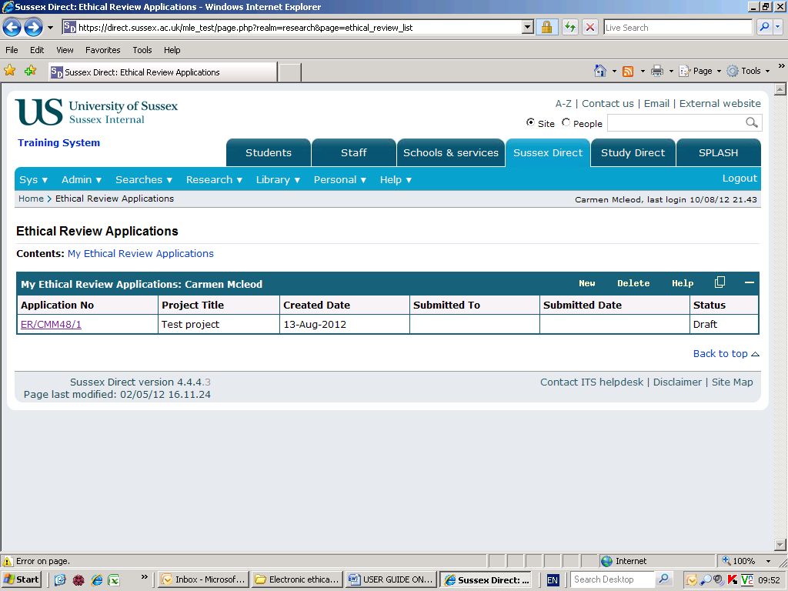

1. **Complete the ‘Create Ethical Review Application’ screen and click ‘Save’;**

**(NOTE: THE SECTIONS MARKED WITH AN ASTERISK* ARE MANDATORY).**

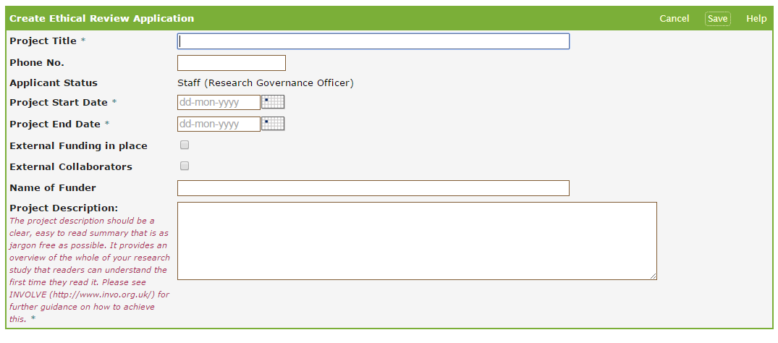

* **\***Project Title
* Phone number
* Applicant Status (automatically populated from the database)
* **\***Supervisor (if you are a student, you must select the name of your Supervisor. Start typing the first two letters of your Supervisor’s surname and a drop down list of University staff will appear from which you can select your Supervisor’s name.
* **\***Project start date (the date you intend starting your research – make sure you allow for the time that the review process will take, as you may not start your research until ethical approval is confirmed).
* **\***Project end date (the date you anticipate your research will be completed).
* External Funding in place – click to insert a tick of this applies
* External Collaborators – click to insert a tick of this applies
* Funder/Project Title (if you have applied for funding through the University, a list of your active applications will be provided as a dropdown list from which you can choose the relevant funder’s name and project title).
* Name of Funder (this box should be completed if you have funding from an organisation where you have not applied through the University).
* **\***Project Description (Up to 400 words).

Click ‘**Save**’ when you have completed this section (you will be able to go back and edit this section, after you have clicked ‘Save’)

NOTE: Click on the ‘**Help’** button if you are need any further information about how to fill out any of these sections.

Click on ‘Help’ for guidance about how to complete this section.

The sections marked with an asterisk are mandatory

**Ethical Review Application Screen:**

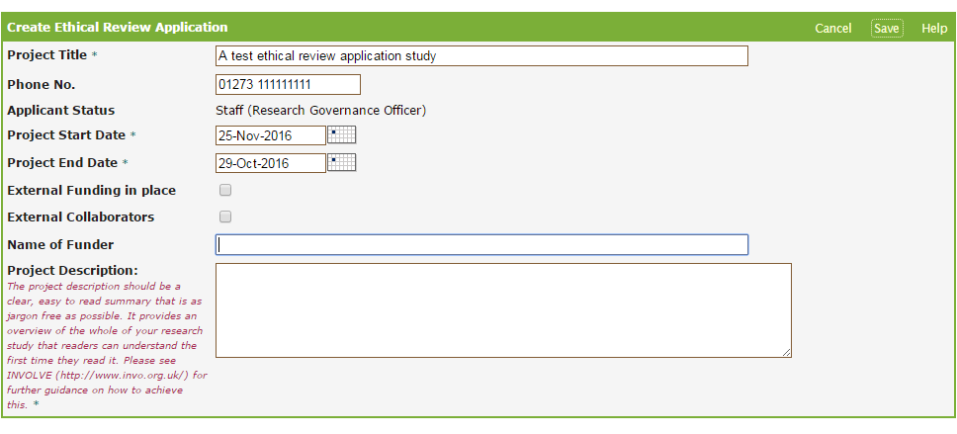

Make a selection and then press ‘Save’.

1. **Choose the correct route for application review**

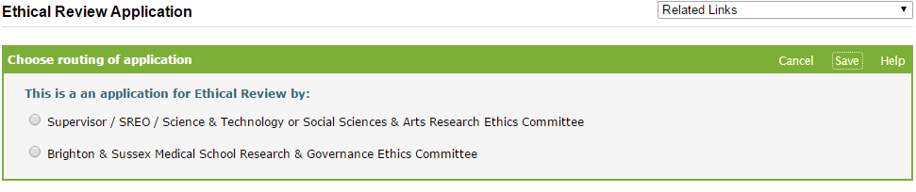

Select the correct route for your application:

* Supervisor/ SREO/ Science and Technology or Social Sciences and Arts Research Ethics Committee – use this for *all* applications other than those destined for review by the BSMS Medical School Research and Governance Ethics Committee (RGEC)
* Brighton and Sussex Medical Research & Governance Ethics Committee – *Only* ethical review applications to this Committee (RGEC) should make use of this option.

**Select ‘Save’ to progress the next stage**

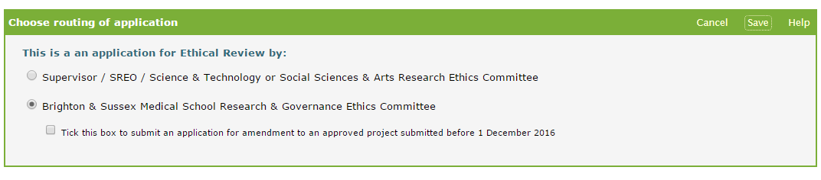

**APPLICATIONS to Brighton and Sussex Medical Research & Governance Ethics Committee (RGEC)**



Having selected the RGEC application route, the first form completed will appear followed by the ‘Ethical Review Form (BSMS version).

### Roles

At the top of the form you are required to provide the details of all investigators in the project’s research team. This will also include Collaborators and Students. Use ‘Other’, giving information under ‘Comments’ when other types of investigators are part of the project.

Click on ‘Add’ to start adding details of investigators in the project’s research team

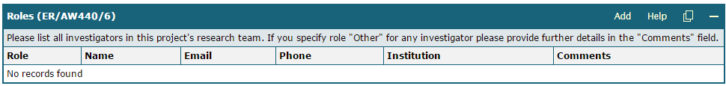

Click on ‘Save+Add’ to start adding details of investigators in the project’s research team

Use the ‘Save+Add’ option to add new roles



Click on ‘Save’’ to start adding details of investigators in the project’s research team

When complete, choose ‘Save’ to close the form



### Ethical Review Form

* **Click on the ‘Edit’ button to start filling out this section**
* Complete the Checklist (you must answer ALL the questions).

Click on ‘Edit’ to start filling out this section, or to go back and make changes after saving

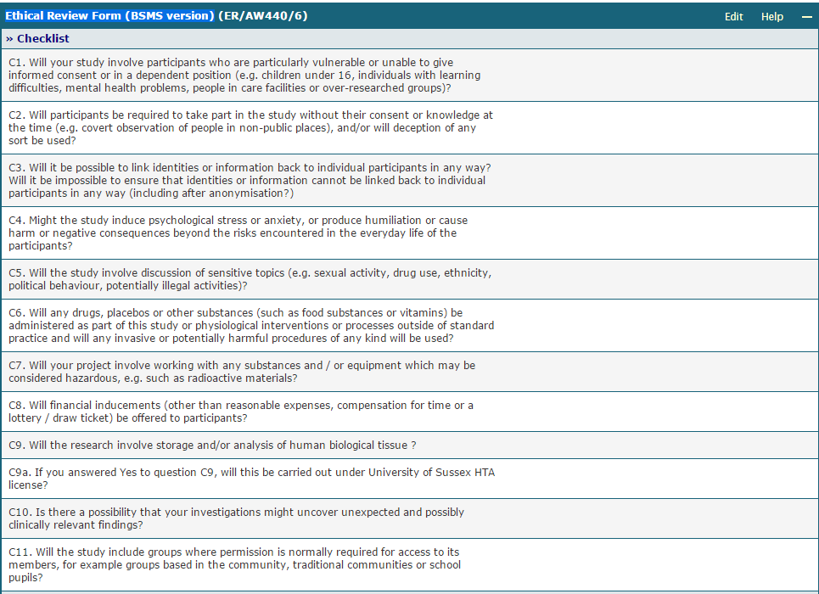

Complete Sections 1-6 of the Form

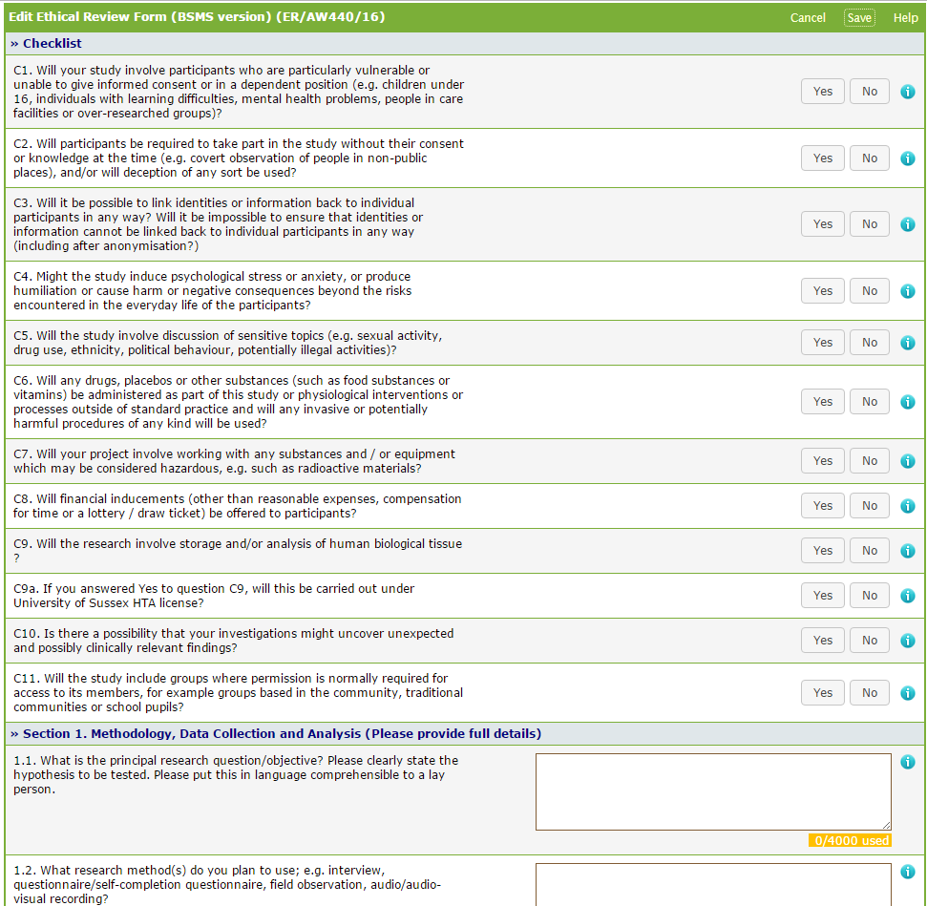

**\*Answers must be provided to each Yes/ No question\***

Select the (i) icon for help text about each question

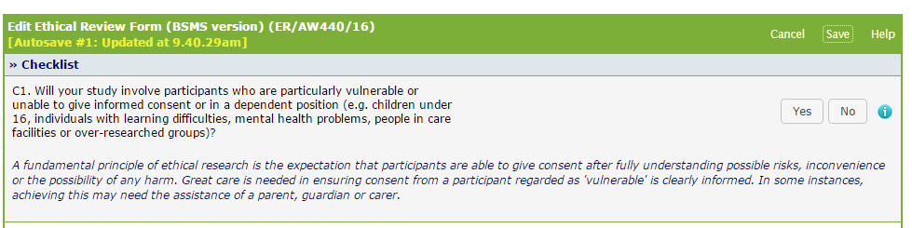

### Supporting Documents

Select **Upload Document**

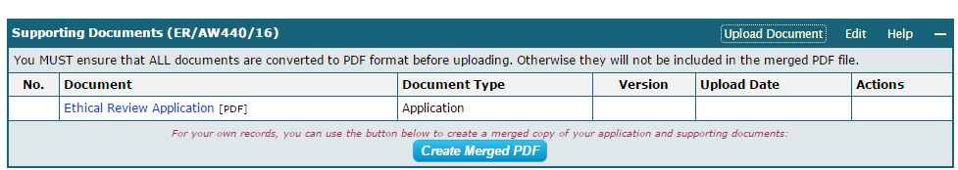

Having completed the form you will need to attach the supporting documents (i.e. Consent Form, Information Sheet, Recruitment materials etc.).

**Each document to be uploaded must be converted to PDF before uploading.**

(an explanation of how to do this is found below)

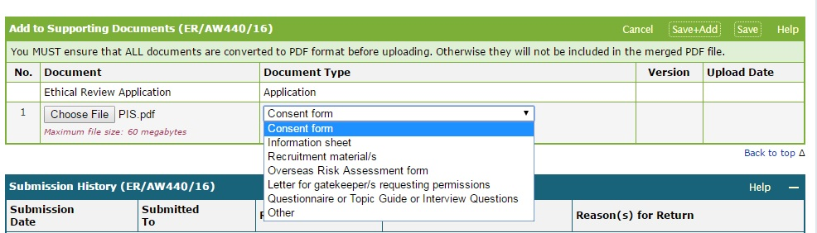

Click on the Upload Document button

1. Click on the Choose File button, and select the document you wish to upload
2. Select the Document Type from the Drop down menu (e.g. consent form, information sheet etc.)
3. Click on the Save button if you have no further documents to upload; Click on the

Save+Add button if you have another document to add

1. Click Replace or Delete in the Actions column, if you need to replace a document

with a different version, or if you want to delete a document.

|  |
| --- |
| **Supporting Documents Box**  You need to upload all your supporting documents in this box. Note: Please ensure that you  convert your documents into PDF BEFORE you upload them.  **Important note**  To make sure your document merges successfully, ITS recommends you follow these  instructions:   * **Using your home PC**   ***Office 2007 or later***  If you are using your home PC with Office 2007, 2010, 2013 or 2016 installed you can save your files in PDF format from your Office application. This is also available if you are using OpenOffice.  In MS Word for example, on the File tab, you will see the option to ***Save as Adobe PDF***    Should this not be possible it is suggest that you use ***Cute PDF*** that can be accessed via - <http://www.sussex.ac.uk/its/services/software/owncomputer>   * **Using an IT Services PC**   If you are using an IT Services PC you should use Corel PDF Fusion:  <http://www.sussex.ac.uk/its/services/software/list?filter=pc&id=293>  If you need assistance with converting your supporting documents into PDF format, please see the following help page on the IT Services website:  <http://www.sussex.ac.uk/its/help/faq?faqid=729> |

### Creating a merged PDF



**PLEASE ENSURE YOU HAVE SAVED YOUR ETHICAL REVIEW FORM‟ BEFORE**

**YOU CLICK THIS BUTTON**

This button allows you to create a merged PDF document of your application form and supporting documents. You will be able to download this for checking, or sharing with a supervisor or research collaborators, before you submit your application.

Note: You do not need to click this button as part of your application submission, but may choose to do so if you want to save a copy of your application, print out a copy of your application, or email a copy of your application. Clicking on the Create Merged PDF button does NOT submit your application for review.

### Declaration

If all necessary sections have been completed you will be presented with a **Declaration** box for you to check before submitting your application to RGEC.

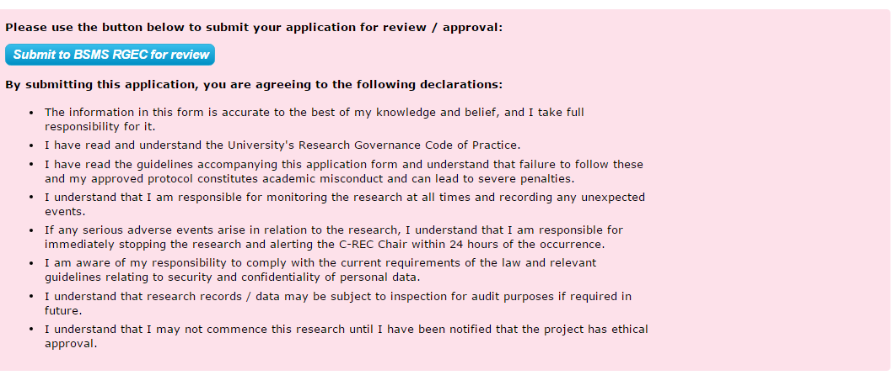

You will be sent an automated email to acknowledge that your application has been submitted for review.

# Amendments

### Amendments to approved applications prior to the introduction of the ethical review system for BSMS

Applicants in BSMS who wish to submit amendments to Ethical Review Applications approved prior to the introduction of the Sussex Direct application system should do the following:

Commence a new application (steps 1 and 2 (pp2- 6 above), In doing so you will need to enter the relevant details of the **previously approved** application.

At step 3 (Choose routing of application), you will need to select both

‘Brighton & Sussex Medical School Research & Governance Ethics Committee’ and ‘Tick this box to submit an application for amendment to an approved project submitted before 1 February 2017’ and then ‘**Save**’

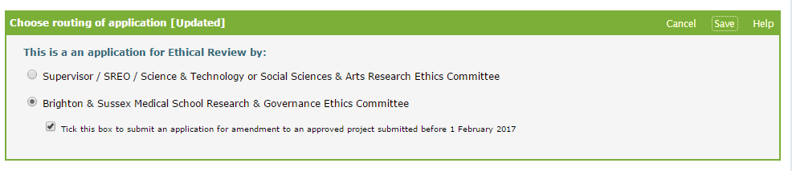

A truncated version of the form will appear -

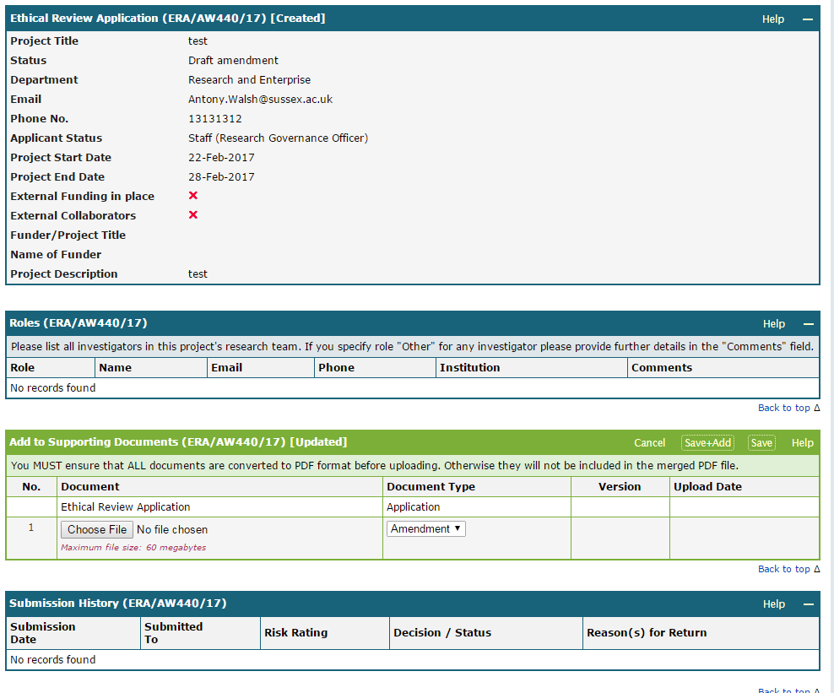

You will be required to submit a completed ‘BSMS Request for Amendment Form’ that will need to be converted to PDF (as described above).

This will be added using the section ‘Add to Supporting Documents’ using the process described in the ‘Supporting Documents’ section above (p.10).

Any accompanying documents that are relevant to the amendment (i.e. revised Consent Form etc.) will also be added here.

Select ‘Save’.

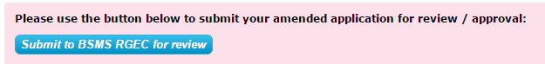

You will then see the declaration form appear and the option to ‘Submit to BSMS RGEC for review’.

An email will confirm that the application has been submitted.

### Amendments to ethical review applications approved within the BSMS ethical review system

The Ethical Review System (ERS) is also used to submit amendments to applications that have been submitted and approved within the ERS.

Applicants need to access the previously approved application –

Access the Ethical Review System in Sussex Direct as indicated in pages 3 and 4 above.

After logging in and accessing ‘Ethical Review’ a list of applications will appear including any that have been approved.

Select the approved application for which you would like to submit an amendment and select ‘Amend’

Select ‘Amend’



Confirm by selecting ‘OK’ that you would like to submit a project amendment

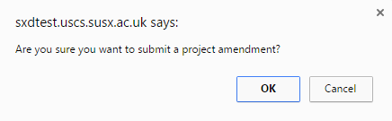

You will be required to submit a completed ‘BSMS Request for Amendment Form’ that will need to be converted to PDF (as described above).

This will be added using the section ‘Add to Supporting Documents’ using the process described in the ‘Supporting Documents’ section above (p.10).

Any accompanying documents that are relevant to the amendment (i.e. revised Consent Form etc.) will also be added here.

Select ‘Save’.



You will then see the declaration form appear and the option to ‘Submit to BSMS RGEC for review’.

An email will confirm that the application has been submitted.