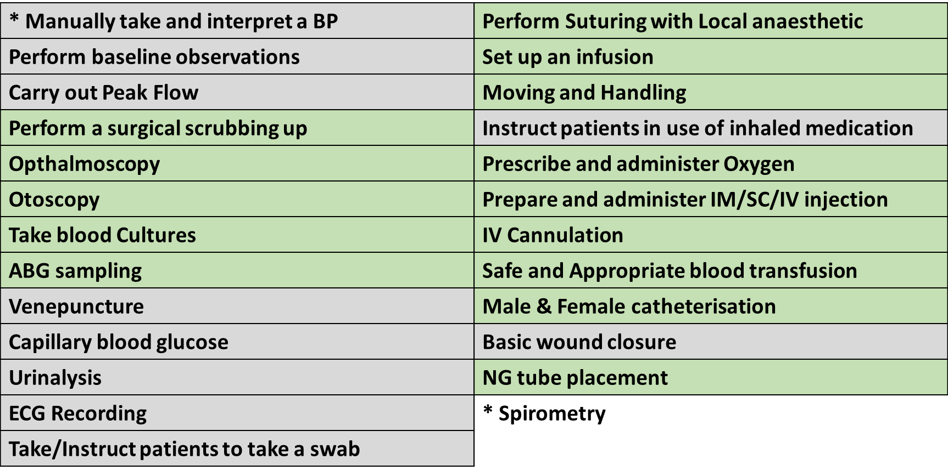Summary of phase teaching

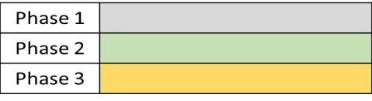**Specific teaching locations**

|  |  |
| --- | --- |
| **Practical Procedure** | **Phase and session** |
| Manually take and interpret blood pressure | Year 1 CTS 2 |
| Peak Expiratory Flow Rate | Year 1 CTS 2 |
| Basic physiological observations | Year 1 CTS 2/ Year 2 CTS 4 |
| Perform direct ophthalmoscopy | Year 4 402 |
| Perform otoscopy | Year 4 402 |
| **Diagnostic procedures** | |
| ECG – record a 12-lead ECG | Year 2 CTS 1 |
| Urinalysis | Year 2 CTS 1 |
| Measure a capillary blood glucose | Year 2 CTS 1 |
| Venepuncture | Year 3 |
| Arterial Blood Gas Sampling | Year 4 Skills Day |
| Blood Culture Sampling | Year 4 Skills Day |
| Take and/or instruct patients how to take a swab | Year 1 CTS 1 |
| **Patient Care** | |
| Moving and handling | Year 3 |
| Perform a surgical Scrubbing up | Year 3 304 |
| Preparation and attachment of IV fluids | Year 4 Skills Day |
| Technique for administration of inhaled medications | Year 2 CTS 2 |
| Administer and prescribe Oxygen | Year 1/ Year 3 module 301 |
| **Therapeutic Procedures** |  |
| Assess wound and carry out basic wound closure | Year 2 CTS 2 |
| Perform Suturing with local anaesthetic | Year 4 Skills Day |
| Prepare and administer injectable (IM, SC, IV) drugs | Year 4 Skills Day (IV)/ Year 2 CTS 2 IM/SC) |
| Intravenous Cannula | Year 3 Skills Day |
| Carry out safe and appropriate blood transfusion | Year 4 Skills Day |
| Female Catheterisation | Year 3 Skills Day |
| Male Catheterisation | Year 3 Skills Day |
| Nasogastric Tube insertions | Year 3 Skills Day |