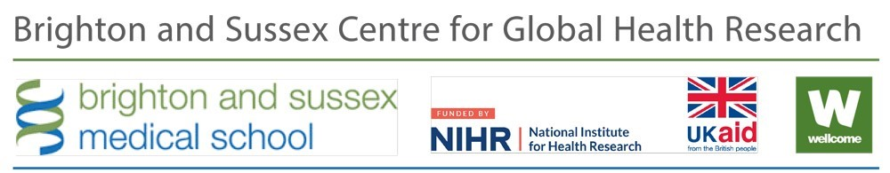

BSMS Global Health Scholarship
  - Academic Year 2022-2023

Application Form

Instructions – Please Read Carefully
Applications to the BSMS Global Health scholarship will be assessed on the basis of the information provided in this form. We therefore advise you to complete this form carefully. Please respect the word limit set. If needed, you may be requested to provide documents proving any information included in this application. If deemed necessary, candidates may be interviewed.

Your completed application form should be submitted by email as a single Word document or PDF file, with BSMS Global Health Scholarship as the subject line. Please email your form to Anne Gatuguta at A.Gatuguta@bsms.ac.uk, along with any supporting documents.

The deadline for applications is 10am (UK Time/UTC+01:00) on Friday 30 June 2023.

Personal Details
Category | Response
Title
Given name
Family name
Date of birth
Gender
Nationality
Disability
Correspondence address
Email address
Telephone number (with international code)
Applicant number

Academic and Professional Background

Summary of educational background
Duration  (from-to)  (month/year) | Degree | Result  (Final Grade) | Date of award  (if expected, please add an ‘E’ after the date)

Relevant work experience and training (including voluntary work and internships
From  (month/year) | To  (month/year) | Employer and Country | Position Held and Duties

Languages and degree of proficiency
Please indicate your level of proficiency (basic, intermediate, advance or native) for Listening, Reading, Speaking and Writing in each language you are proficient in.
Language | Listening | Reading | Speaking | Writing
English
If English is not your first language please indicate the results of your IELTS or TOEFL test

References
Please give the names, positions held, email and telephone numbers of THREE referees.
Referee | Details
Referee 1
Referee 2
Referee 3
You will need to ask one of these referees to provide a reference letter in support of your application. This must be sent to A.Gatuguta@bsms.ac.uk by the deadline (Subject Line: Reference/GH Scholarship/Applicant’s Name). Referees would need to comment on your interest in Global Health, your academic and professional merits and your financial need.

Motivation Letter
Please explain in no more than 700 words why you are applying for this MSc in Global Health and for this Scholarship and what you expect from it. How will the MSc in Global Health and Scholarship help develop your career?

Motivation Letter (continued)

Additional Information

Past prizes, awards or scholarships (please attach copies to your application)

Conferences attended (please attach copies of the certificates of attendance to your application)

How have you funded your studies to date? (Please provide evidence of loan/grant)

Other sources of funding that you have applied for and outcomes (please specify sources of funding and include submission/expected outcome dates)

If you were offered the BSMS Global Health Scholarship, how would you fund the rest of the costs associated with the MSc in Global Health?

Is there any other information that you think the assessors should know about your circumstances (e.g. relevant publications, etc.

How did you learn about the BSMS Global Health Scholarship
☐ Web and Newsletter/News Alert
☐ Direct Contact from BSMS
☐ University Webpage
☐ Friends/Previous Students/Colleagues
☐ Other (please specify):

Declaration
By submitting this document, I hereby certify that the information provided in this application form is accurate.
Name: Date and Place:

Please submit your application by 10am on Friday 30 June 2023 (UK time)

