Postgraduate Certificate Simulation in Clinical Practice 2019/20 Application Handbook

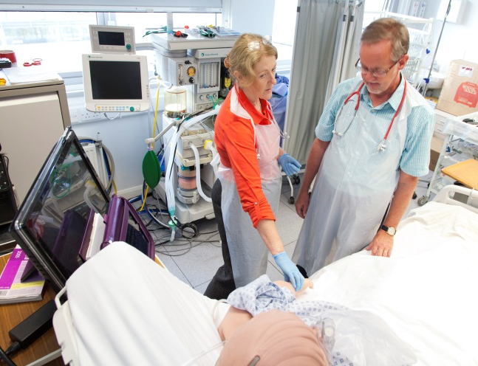

Course Leader:
Dr Wesley Scott-Smith
W.Scott-Smith@bsms.ac.uk
Course Administrator:
Andrew Collins
A.Collins@bsms.ac.uk

Contents

Introduction 4
Aims and Learning Outcomes for the Course 4
Aims 4
Learning Outcomes 4
Entry Requirements 5
Course Structure 6
Module Descriptors 6
MDM148 Principles and Practice of Simulation in Clinical Practice 6
MDM149 Feedback and Debriefing 6
MDM28 Teaching and Learning in Medical Education 7
Timetable 7
Fees 8
Teaching Staff 8
Teaching and Learning Methods 8
Assessment 8
Assessment of modules 8
How to Apply 9

Introduction

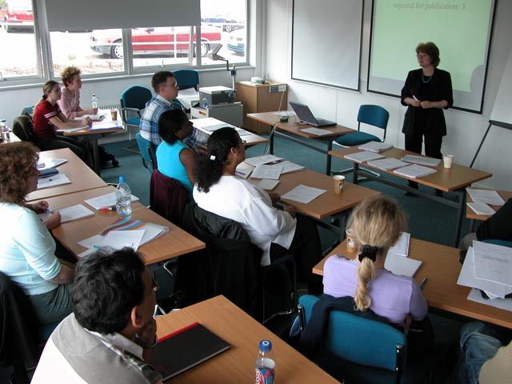
The Postgraduate Certificate in Simulation in Clinical Practice is a new course which has been developed to meet the needs of NHS practitioners and trainers in whose responsibility is to deliver Simulation Based Education (SBE). This is aligned to the national and local strategies in Technology Enhanced Learning (TEL) advocated by Health Education England. The course is based within Brighton and Sussex Medical School, and is jointly validated by the University of Brighton and the University of Sussex. However it is suitable for all types of roles within the NHS and higher education, and it is delivered using a multi-disciplinary approach with members of the Sussex Simulation Hub.

Aims and Learning Outcomes for the Course

Aims
This course aims to provide a sound basis of knowledge and experience for practitioners undertaking SBME delivery in their local trust or higher education institution.
The course objectives are:
- The rigorous application of sound educational principles applied to simulation based medical education.
- An emphasis on multi-professional potential and focus of simulation activities
- A strong ethos of evaluation, assessment and research to underpin the development of simulation based programmes in clinical practice
- Group-work activities which immerse the learner in the essential features of SBME. E.g. Feedback and debriefing
- A work based portfolio documenting evidence of teaching in SBME in the workplace, including peer observation of practice, self-evaluation and reflective discussion.

Learning Outcomes
On successful completion of this course, you will be able to:
- Demonstrate a critical understanding of how educational principles can be applied to various forms of simulation based learning.
- Demonstrate in-depth knowledge of the broad typology of simulation strategies linked to learning outcomes, context and fidelity.
- Show a critical understanding of feedback and debriefing used commonly in simulation
- Demonstrate a critical awareness of the evidence base underpinning simulation based learning.
- Understand and demonstrate a critical awareness of aspects of debriefing.
- Apply outcomes from the module to simulation based training in practice, and be able to assess and evaluate the training and its impact upon learning and patient care
- A critical awareness of how to apply feedback in the context of simulation based learning.
- Understand and demonstrate the principles of critical reflection to reconstruct practice.
- Demonstrate a deep understanding of the concept of transformative learning and the role of extrinsic and intrinsic feedback in reconstructing practice.
- Facilitate learning in both academic and practice settings.
- Develop and enhance their teaching skills in medical education.
- Gain an awareness and familiarity in enhanced technology in medical and health education, and demonstrate a critical understanding and evaluation of major research designs and their relative strengths and limitations
- Demonstrate a critical understanding and evaluation of major research designs and their relative strengths and limitations.
- Systematically develop and justify a chosen research approach and methodology to investigate a specific topic within their subject.
- Produce a research proposal which demonstrates appreciation of scientific methods appropriate to their specialist area.
- Critically appraise a variety of research papers across a range of study designs.
- Carry out an appropriate, rigorous review of the literature.
- Be aware of ethical and governance issues in research.

Entry Requirements

Applications are welcome from trainers in medicine and nursing and from other specialisms in the health and social care professions. Current employment in a clinical role which includes teaching or developing simulation-based education is essential with evidence of prior study at Bachelors level or equivalent.
This course is only open to applications from UK/ EU/ Island residents.
There will be an Induction Day on Thursday 12th September 2019 for all successful applicants and you are strongly recommended to attend.

Course Structure

Module | Status
MDM148 Principles and Practice of Simulation  MDM149 Feedback and Debriefing in Simulation  MDM28b Teaching and Learning in Medical Education | Mandatory (20 credits)  Mandatory (20 credits)  Mandatory (20 credits)

Module Descriptors

MDM148 Principles and Practice of Simulation in Clinical Practice
This module directs you towards a deeper understanding of the underlying educational principles that form the basis of the various applications involved in Simulation Based Medical Education (SBME), and will enable you to develop teaching and learning in the practice setting.

It will provide illustrations of key educational principles involved in SBME through practical workshops/group work, covering key issues such as choosing the correct method in your teaching/research, high and low fidelity methods, simulated patients (SP), feedback and debriefing, the typology of SBE, virtual simulation, assessment and evaluation.

The module is assessed by means of a 3,000 word written assignment focused upon an area of SBME that is relevant to your clinical role (Full details of this are given in the Module Handbook.)

NB. This module can be taken as a stand-alone option for CPD, or can be part of the Postgraduate Certificate of Simulation in Clinical Practice, and applications from all disciplines within healthcare are welcomed.

MDM149 Feedback and Debriefing
This module will deliver a blend of practical sessions and group work to illustrate various approaches to the core activities of feedback and debriefing within SBME. Participants will be expected to enter into group work scenarios focused on areas such as exploratory discourse, and more conventional feedback associated with psychomotor tasks.

An important aspect of this module will be taking forwards some of the theories and ideas into a portfolio, which will demonstrate skills and competencies through teaching in the workplace. Students will be expected to produce a portfolio of teaching practice covering five separate episodes, and include in this peer observation of teaching, self-evaluation, and reflective analysis.
Modular assessment is by means of successful completion of the portfolio.

Participants will be expected to produce a 5000 word portfolio which will include 5 sessions of teaching with Peer observation of teaching (POT) for personal development, to include reflective accounts of learning through teaching, from a personal perspective and that of the learner e.g. issues that arise with feedback.

MDM28b Teaching and Learning in Medical Education
The module will enable the participants to reflect upon their previous teaching and learning, and to explore and apply educational theories to their current and future teaching and professional practice. Technology enhanced learning and evidence based educational practice will be central to his module.

The module aims to ensure the teacher is also a learner by enabling the participants to:

- Facilitate learning in both academic and practice settings;
- Learn in both academic and practice settings
- Develop and enhance their teaching skills in medical education.
- Gain an awareness and familiarity in enhanced technology in medical and health education

The module is assessed by means of a 3,000 word written assignment. (Full details of this are given in the Module Handbook.)

Timetable

We recommend students to take a maximum of 2 modules per academic year due to the demands of the course. Usually students complete MDM148 and MDM149 in Year 1, and MDM28C in Year 2. The dates for these modules are shown below.

If you need to complete the entire PG Cert in 1 year please discuss this with the Course Leader.

Year | Month | Induction day | Principles and Practice of Simulation (MDM148) | Feedback and Debriefing in Simulation (MDM149) | Learning and Teaching in Medical Education (MDM28C) | Semester
2019 | Sep | 12 September |  |  |  | SEM 1
 | Nov |  | 25, 26, 27, 28, 29 November
 | Dec
2020 | Jan |  |  | 27, 28, 29  January
 | Feb |  |  |  |  | SEM 2
 | Mar
 | Apr |  |  | 1 April
 | Nov |  |  |  | TBC | SEM 1
 | Dec |  |  |  | TBC
2021 | Jan |  |  |  | TBC
 | Feb |  |  |  | TBC | SEM 2
Total attendance days |  | 1 | 5 | 4 | 4
Assignment Date |  |  | 4 Feb 2020 | 2 June 2020 | TBC

Fees
For fee information please contact: fees@brighton.ac.uk or visit the following link:

http://www.brighton.ac.uk/studentlife/money/

Teaching Staff

Academic staff from Brighton and Sussex Medical School and other faculties in the Universities of Brighton and Sussex are involved in the provision of teaching in a modular format, at Masters (M) level. Specialist teaching is provided by consultants, specialists and other clinical staff from Trusts and organisations in and around the region. The extensive contribution of expert practitioners to the teaching of the modules is a distinctive feature of courses at Brighton and Sussex Medical School.

Teaching and Learning Methods

As with all Masters courses, there is a considerable degree of independent study. Teaching methods encompass lectures, whole group discussions, small group discussions, critical appraisal workshops and individual tutorials. Maintaining employment throughout the course ensures the transfer of knowledge
and skills from the course into the workplace.

Assessment

Modules are assessed by summative essays and Peer Observation of Teaching sessions (MDM149 only). More details are provided in the individual module handbooks, and will be discussed in detail during teaching sessions at the University.

Assessment of modules
Assessments are intended to ensure that you have achieved the learning outcomes for the modules that you have taken. The details of assessment for each module will be available in the individual module handbooks. It is usual for assignments to be relevant both to the module and to your own personal and professional development needs. Please see the table below for details of the grades awarded.

Percentage | Level
70% - 79% | Distinction
60% - 69% | Merit
50% - 59% | Pass
40% - 49% | Fail / Refer
<40% | Fail

How to Apply
Please apply online via the following link:
http://www.bsms.ac.uk/postgraduate/taught-degrees/

If you have any further questions please contact the Programme Administrator via the email address on the cover page.

