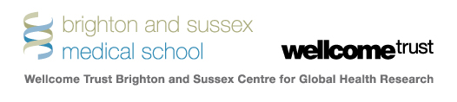

Research Development Fund

Application form

- YOUR DETAILS
- Applicant’s name

- Title
Dr Mr Mrs Ms Miss Other __________

- Date of birth (dd/mm/yyyy)

- Title of project

- Contact details – full address
Address

Email

Direct telephone number

Department telephone number

- Applicant’s employing organisation

- Job title

- Relevant qualifications (most recent first)

- Previous professional experience (most recent first)
Dates | Employer/Organisation | Position

- Research and publications
List your publications and presentations (your name in bold)

- THE PROJECT

- What is your research question? (no more than 100 words)

- Please provide a summary of your proposed research including key goals:

- For scientifically qualified assessors (no more than 300 words)

- For lay readers (no more than 300 words)

- Details of your project – this can be attached as a separate document
Please explain in less than 1500 words:
- the project background, context and need
- the study design
- who will benefit from the research project
- what the ethical considerations are
- a timetable of activities and milestones for your proposed work

- Amount requested
(maximum £10,000)
£

- Project budget
(detailed breakdown of the funds requested)
Item | £
Total

- Justification for funding (why you need what you are asking for, and an explanation for the amounts you are requesting, max 300 words)
Notes:
Please calculate in UK £ sterling
Maximum value of grant is £10,000; allowable expenses include economy travel and accommodation, consumables, field expenses including stipends or per diems, field transport, small items of equipment or software.

Referees
Please ask two referees acquainted with your qualifications, one a senior member of the Brighton & Sussex Wellcome Trust Global Health Research Centre in your country and the other a direct supervisor, to email a letter of support with your name in the document title direct to globalhealth@bsms.ac.uk

Applicants are responsible for ensuring that their referees submit references by the closing date. Un-refereed applications will not be considered.

Please email your completed application form to globalhealth@bsms.ac.uk.

Applications will be acknowledged by email.

In the event of a successful application I agree to abide by the Regulations

Signature

Date

The Wellcome Trust Brighton and Sussex Centre for Global Health Research
Brighton and Sussex Medical School
The University of Sussex
BN1 9PX
globalhealth@bsms.ac.uk

